**FADING**

Fading is a phenomenon that occurs due to varying parameters and conditions of the channel during wireless propagation. To better understand and eliminate the adverse effects of fading, it is divided into various types. Let us take a look into them in detail.

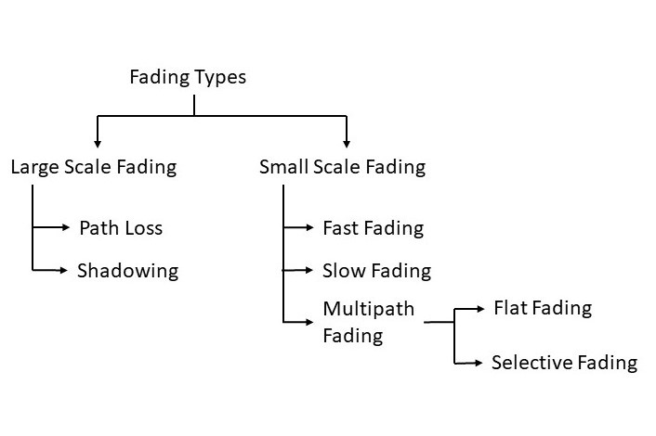

The figure above shows the different types of fading and the sub-categories. We have tried to elaborate on each type of fading below and provide information on how do they affect wave propagation.

**1. Large Scale Fading:** This refers to the attenuation of signal power due to obstacles between the transmitter and receiver. It also covers the attenuation and fluctuations of signal when the signal is transmitted over a long distance (usually in kilometres).

* **Path Loss:** It refers to the attenuation when a signal is transmitted over large distances. Wireless signals spread as they propagate through the medium and as the distance increases, the energy per unit area starts decreasing ([Click here to try the Path Loss Calculator](https://www.everythingrf.com/rf-calculators/free-space-path-loss-calculator)).This is a fundamental loss that is independent of the type of transmitter and medium. Although, we can minimize its effects by increasing the capture area/dimension of the receiver. The figure below shows the [radiation pattern](https://en.wikipedia.org/wiki/Radiation_pattern) and spread of the signal transmitted from the antenna.

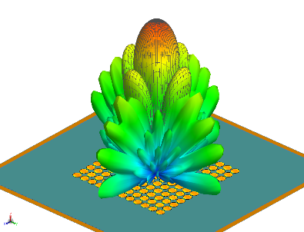

* **Shadowing:** This refers to the loss in signal power due to the obstructions in the path of propagation. There are a few ways in which shadowing effects can minimize signal loss. One that is most effective, is to have a Line-Of-Sight propagation.  
    
  Shadowing losses also depend on the frequency of the EM wave. As we know, EM Waves can penetrate through various surfaces but at the cost of loss in power i.e signal attenuation. The losses depend on the type of the surface and frequency of the signal. Generally, the penetration power of a signal is inversely proportional to the frequency of the signal.

**2. Small Scale Fading:** This refers to the fluctuations in signal strength and phase over short distance and small duration of time. It is also called Rayleigh Fading. Small Scale Fading affects almost all forms of wireless communication and overcoming them is a necessity to increase efficiency and decrease error.

* **Fast Fading:** It occurs mainly due to reflections for surfaces and movement of transmitter or receiver. High [doppler spread](https://electronics.stackexchange.com/questions/123427/what-is-doppler-spread" \t "_blank) is observed in the fast fading with Doppler bandwidth comparable to or greater than the bandwidth of the signal and the channel variations are as fast or faster than the signal variations. It causes linear distortions in the shape of the baseband signal and creates [Inter Symbol Interference (ISI)](https://en.wikipedia.org/wiki/Intersymbol_interference). One way to remove ISI is [adaptive equalization](https://en.wikipedia.org/wiki/Adaptive_equalizer).
* **Slow Fading:** It occurs mainly due to shadowing where large buildings or geographical structures obstruct the LOS. Low doppler spread is observed in Slow Fading with the doppler bandwidth being smaller compared to the bandwidth of the signal and the channel variations are slow relative to the signal variations. It results in reduction of SNR which can be overcome using error correction techniques and receiver diversity techniques.
* **Multipath Fading:** It occurs when a signal reaches the receiver from various path i.e. when multipath propagation takes place. Multipath fading can affect all ranges of frequencies starting from low frequency to microwave and beyond.

Multipath Fading

* In wireless telecommunications, multipath is the propagation phenomenon that results in radio signals' reaching the receiving antenna by two or more paths. Causes of multipath include atmospheric ducting, ionospheric reflection and refraction, and reflection from terrestrial objects, such as mountains and buildings.
* The effects of multipath include constructive and destructive interference, and phase shifting of the signal. This causes Rayleigh fading, named after Lord Rayleigh. The standard statistical model of this gives a distribution known as the Rayleigh distribution.
* Rayleigh fading with a strong line of sight content is said to have a Rician distribution, or to be Rician fading.
* In facsimile and television transmission, multipath causes jitter and ghosting, seen as a faded duplicate image to the right of the main image. Ghosts occur when transmissions bounce off a mountain or other large object, while also arriving at the antenna by a shorter, direct route, with the receiver picking up two signals separated by a delay. In radar processing, multipath causes ghost targets to appear, deceiving the radar receiver. These ghosts are particularly bothersome since they move and behave like the normal targets (which they echo), and so the receiver has difficulty in isolating the correct target echo. These problems can be overcome by incorporating a ground map of the radar's surroundings and eliminating all echoes which appear to originate below ground or above a certain height. In digital radio communications (such as GSM) multipath can cause errors and affect the quality of communications. The errors are due to Intersymbol interference (ISI). Equalisers are often used to correct the ISI. Alternatively, techniques such as orthogonal frequency division modulation and Rake receivers may be used.

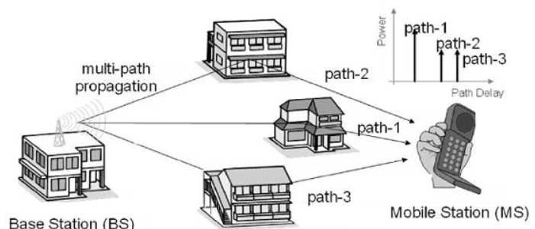

Causes of Multipath Fading

It includes atmospheric reflection and refraction, and reflection from water bodies and terrestrial objects such as mountains and buildings.

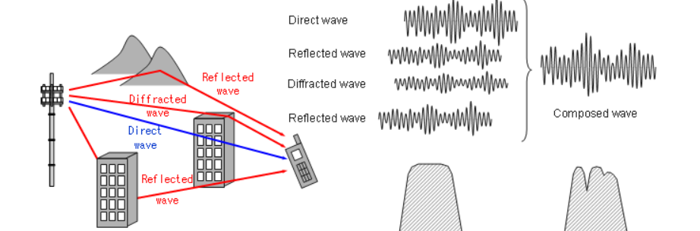

It affects both the amplitude and the phase of the signal causing phase distortions and ISI. Multipath fading can affect signal transmission in two ways:

* + **Flat Fading:** In flat fading, all frequency components get affected almost equally. Flat multipath fading causes the amplitude to fluctuate over a period of time.
  + **Selective Fading:** Selective Fading or Selective Frequency Fading refers to multipath fading when the selected frequency component of the signal is affected. It means selected frequencies will have increased error and attenuation as compared to other frequency components of the same signal. This can be overcome by techniques such as OFDM which spreads the data across the frequency components of the signal to reduce data loss.